Odoo – Helpdesk Manager Guide

Contents

Purpose 1

Helpdesk Teams 1

Creating Helpdesk Teams 2

Ticket Tags 4

Creating a Tag 4

Ticket Scopes 4

Creating Ticket Scopes 4

Ticket Types 5

Creating Ticket Types 5

Ticket Stages 6

Creating a Ticket Stage 6

Ticket SLA’s 7

Ticket Causes & Actions Taken 8

# Purpose

The purpose of this document is to describe all the configuration components of the Odoo Helpdesk Module. After reading this document, you should be able to create new support teams with or without team members and configure SLA’s, Scopes, Tags and Ticket Types.

# Helpdesk Teams

When you first open the Helpdesk App, the users will see all of the teams they have visibility to, as well as their own Ticket stats. Each team is a self-contained place that’s home to their own Tickets and SLA’s. If a user belongs to multiple teams then they can move Tickets between the teams but if a user does not belong to a team, then that team is invisible to them.

Quick Tips:

* A Helpdesk Team can be set to be visible to specific users or to all users.
* Helpdesk Teams have their own SLA’s (if enabled for that team).
* Users will only see teams that they are a part of.
* Helpdesk Teams can have individual email aliases where tickets get created when emails come into that email address.
* Each Helpdesk Team can have its own Ticket Stage, or they can share stages.
* Each Helpdesk Team can have its own Ticket Scopes, or they can share scopes.
* Ticket Tags are global and available to all Teams.

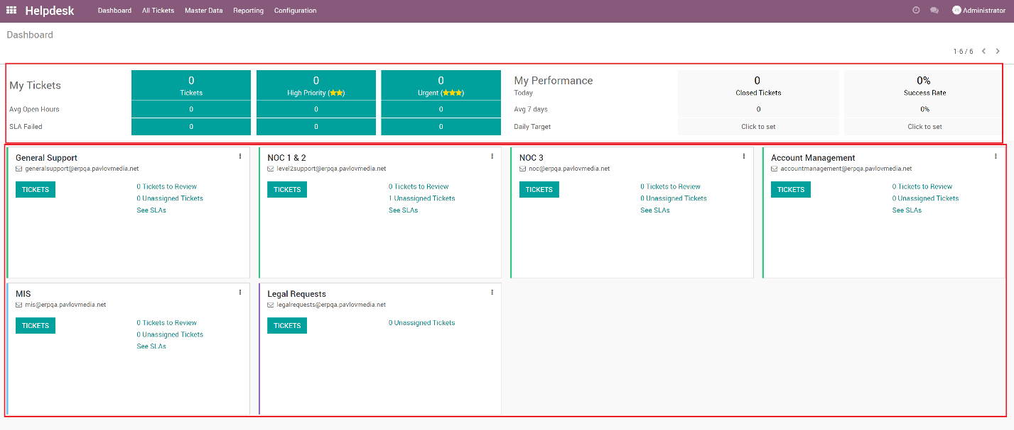

## Creating Helpdesk Teams

In order to create Helpdesk Teams, ‘Manager’ permissions are needed.

1. Go to **Configuration**
2. Click **Settings**

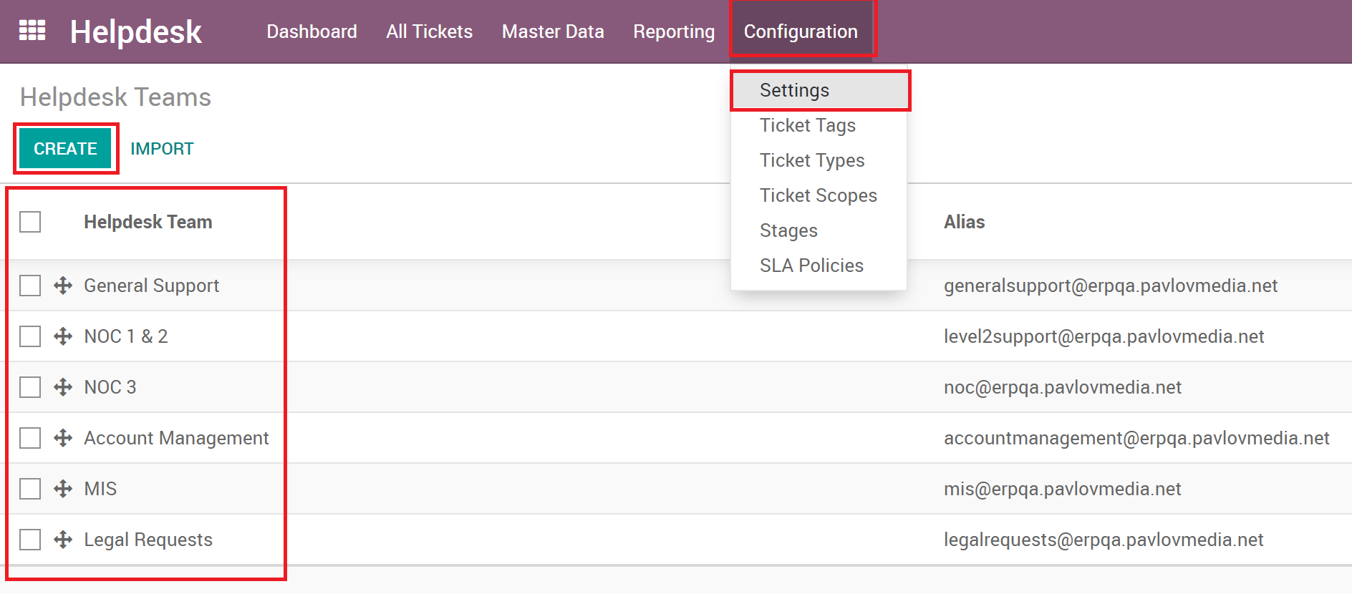

1. You will see the list of Teams and can move the order of how the teams look on the dashboard. Note that the order is reflected for all users.
2. Either open an existing team or press the **Create** button to create a new one.

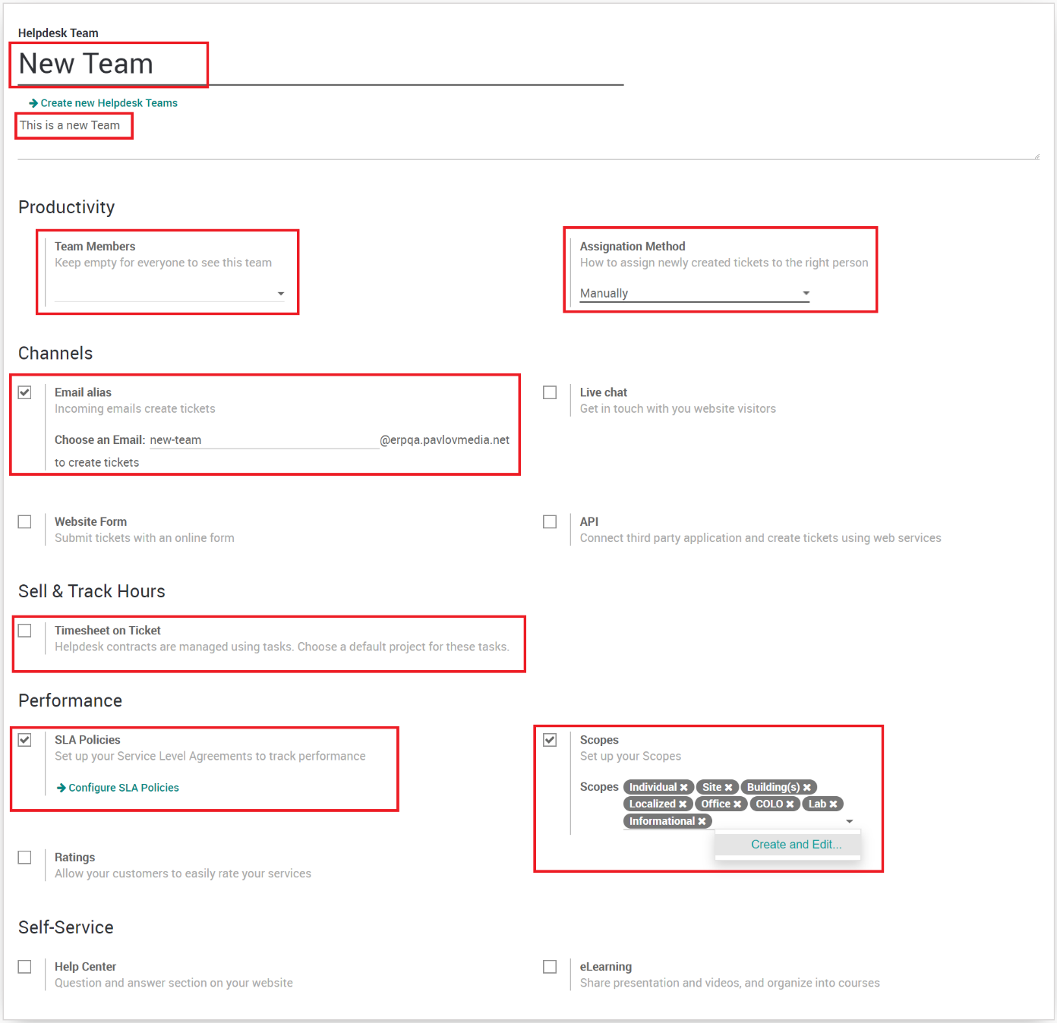

1. Enter the needed information and select the settings needed for this team depending on the company’s needs.
   1. **Name**: The name of the team.
   2. **Description**: Description of the team.
   3. **Team Members**: If blank, the team is visible to all users, otherwise select the team members to lock the team to certain users.
   4. **Assignation Method**: Tickets can be automatically assigned to users or manually assigned.
   5. **Email Alias**: The email address to use for auto creation of tickets.
   6. **Live Chat**: Odoo has a simple chat client for its customer website.
   7. **Website Form**: Adds a ticket submission form to the Odoo website.
   8. **API**: Allows tickets to be created via API
   9. **Timesheet on Ticket**: Connects Tickets to Projects and Tasks for time tracking.
   10. **SLA Policies**: Allows SLA’s for tickets on this Team.
   11. **Scopes**: Scopes can be Team specific and added here, they are also configurable in the configuration section.
   12. **Ratings**: This enables Ratings to be sent to customers once the ticket is moved to solved stage. Ratings are simple, just using three smiley faces that customer would click to rate their experience. Surveys might provide a more useful rating method.
   13. **Help Center**: Adds a questions/answers section on the Odoo customer website.
   14. **eLearning**: Adds presentations, videos and courses on the Odoo customer website.
2. Click **Save**.

# Ticket Tags

Ticket tags are a simple way to add multiple items to a ticket and can be used however the company wishes. Tags are global and are available to all teams. In order to manage Tags, the user must have ‘Manager’ permissions.

## Creating a Tag

1. Enter **Debug** **Mode**
2. Go to **Configuration**
3. Click **Ticket Tags**
4. Click the **Create** button

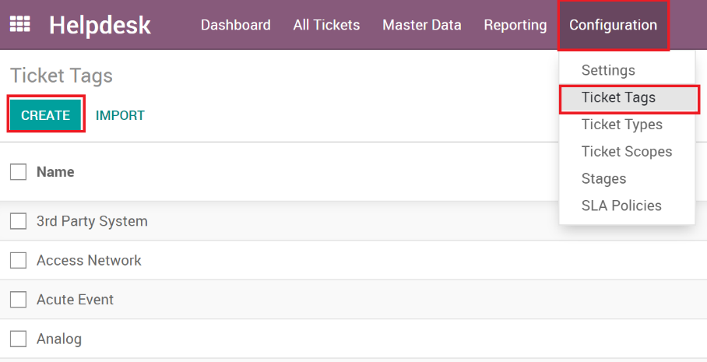

1. Name your Tag
2. Click **Save**

# Ticket Scopes

Ticket Scopes give the ability to categorize the Tickets and is used as the parent to Ticket Types. Scopes generally describe the extent of the area or subject matter that the Ticket deals with or to which it is relevant to.

## Creating Ticket Scopes

1. Go to **Configuration**
2. Click **Ticket Scopes**
3. Click the **Create** button

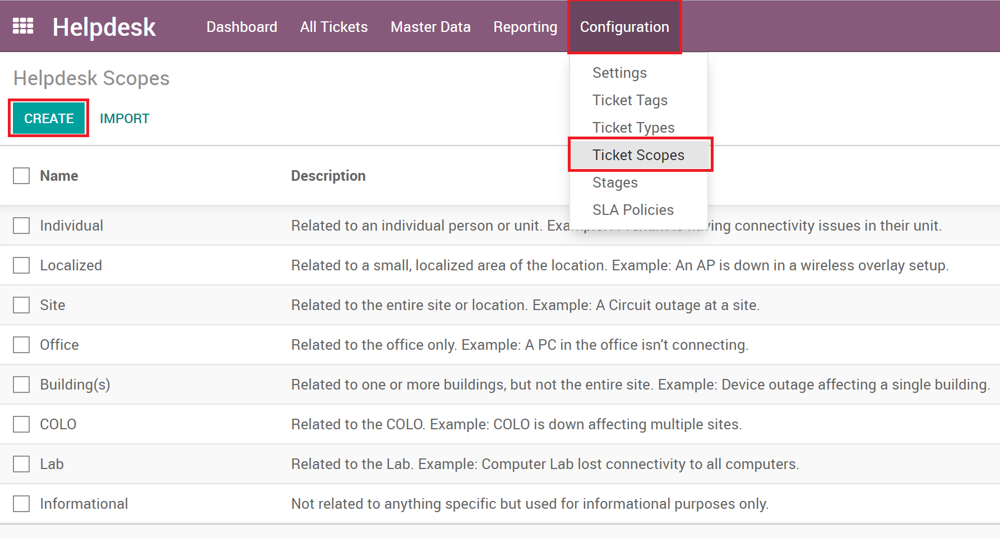

1. Enter **Name** and **Description**
2. Click **Save**
3. Now you can go to the different Teams and add the scope to the teams who should have access to it.

# Ticket Types

The Ticket Type is used to specify the Ticket and triggers any SLA that are based on the Ticket Type. Ticket Causes and Actions Taken also are linked to the Ticket Type. Ticket Types have a default priority and are related to Scopes.

## Creating Ticket Types

1. Enter **Debug Mode**
2. Go to **Configuration**
3. Click **Ticket Types**
4. Click the **Create** button

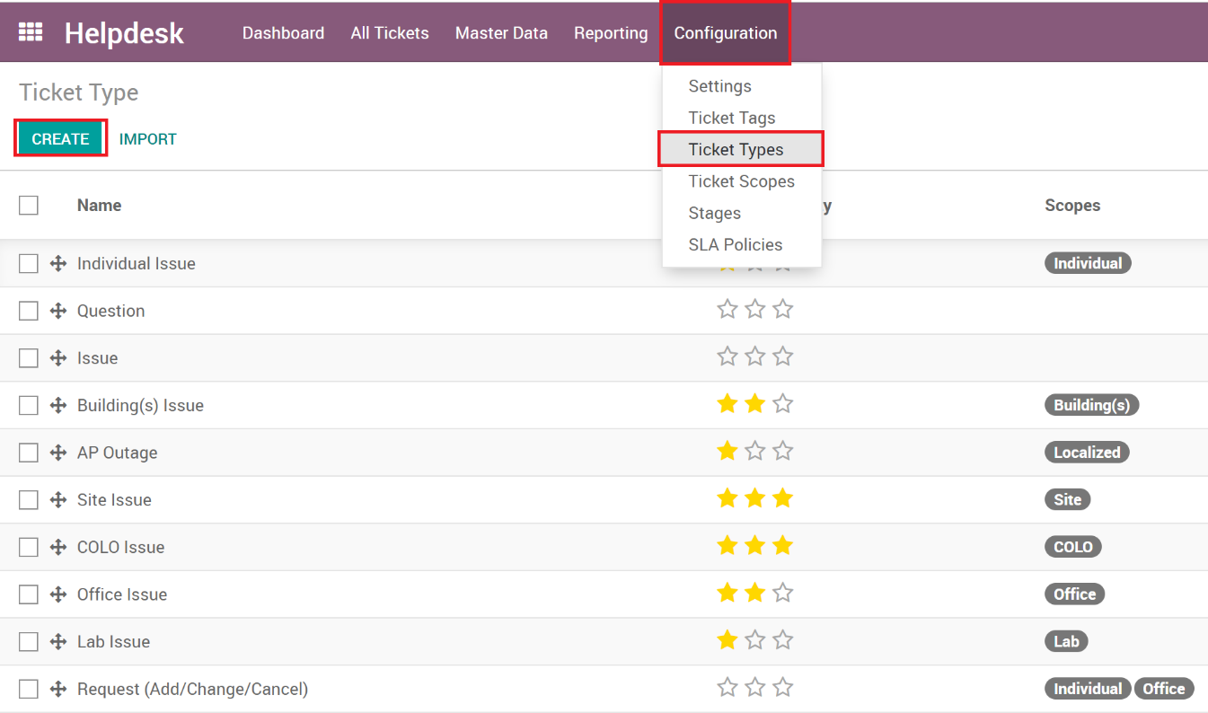

1. Enter the relevant information:
   1. **Name**: Name of the Ticket Type.
   2. **Default Priority**: The priority will auto set on the Ticket when you select the Ticket Type.
   3. **Scopes**: Select all the scopes that this Ticket Type will be available for.
2. Click **Save**
3. Now users will see the new Ticket Type when they select one of the scopes you set.

# Ticket Stages

Stages can be described as the status of the Ticket. Stages can be used by individual Teams or multiple teams can have the same stage.

## Creating a Ticket Stage

1. Enter **Debug Mode**
2. Go to **Configuration**
3. Click **Stages**
4. Click the **Create** button

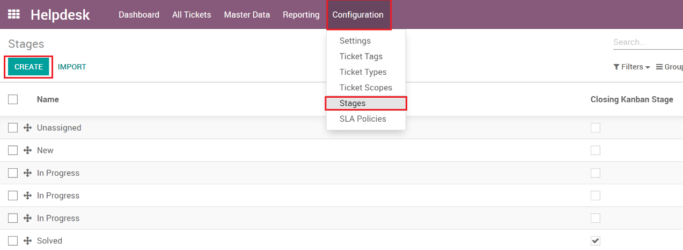

1. The new stage form will open

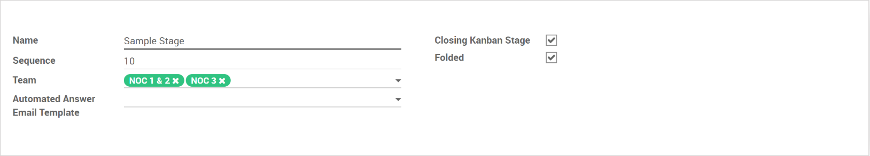

1. Enter the needed information:
   1. **Name**: Name the Stage.
   2. **Sequence**: Specify the order this stage falls in compared to other stages.
   3. **Team**: Stages can belong to a single team or multiple teams. Keep in mind that if you have multiple teams with one stage, and you make changes to the stage, it’s reflected on each related team. Also, if the teams share the stage, and you move it from one team to another, it keeps that status and won’t reset the status when moved. This can cause problems, especially if its set to ‘in progress’ in team1, and you want it to set to ‘unassigned’ when moved to team2. It might be best to have a stage for each team, even if the names are the same.
   4. **Automated** **Answer Email Template**: Odoo allows email templates which will email the contact/customer whenever the ticket moves to this stage. Leave blank to send no emails. No other logic is used for sending emails using this out of the box feature.
   5. **Closing Kanban Stage**: Sets the stage as a ‘closed’ or ‘completed’ stage, used for filtering.
   6. **Folded**: Shows as compressed on the Kanban view.

# Ticket SLA’s

SLA’s track the time a Ticket is open

Creating SLA’s

1. Go to **Configuration**
2. Click **SLA Policies**
3. Click the **Create** button

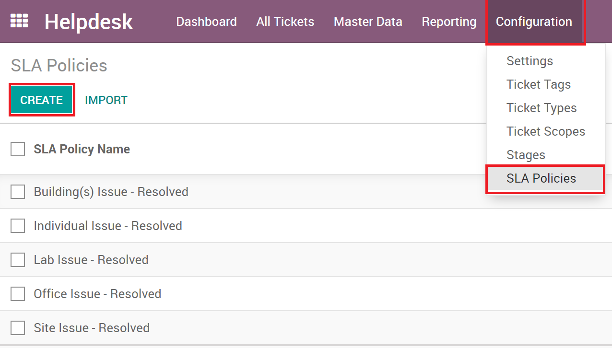

1. The SLA form will open

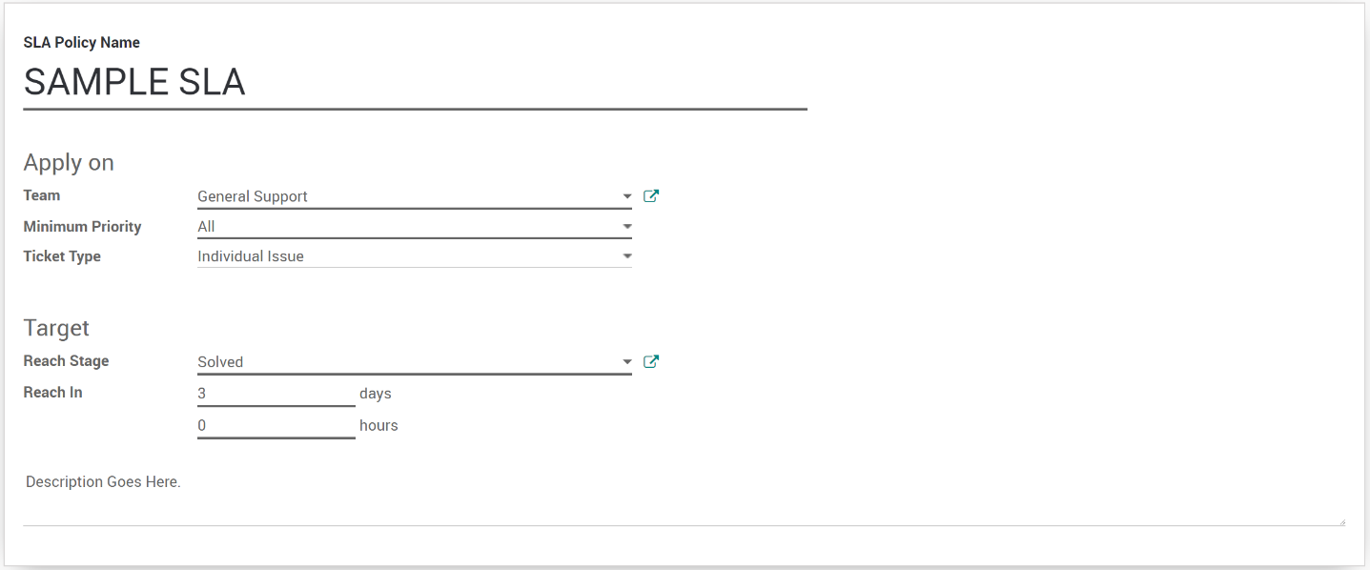

1. Enter the needed information:
   1. **Name**: The name of the SLA
   2. **Team**: What Team is responsible for this SLA
   3. **Minimum Priority**: The specific priority this SLA is triggered.
   4. **Ticket Type**: What Ticket Type the SLA is triggered.
   5. **Reach Stage**: The stage for the SLA timer to be considered done.
   6. **Reach In**: How many Days/Hours till the SLA is considered success or failure.
   7. **Description**: Description of the SLA.
2. Click **Save**

The SLA will be reflected on the ticket with a Color and Deadline, as well as on the dashboards via Tickets to Review.

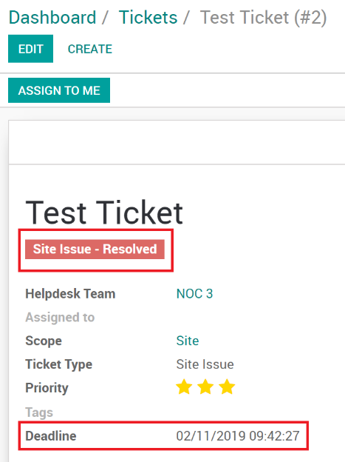 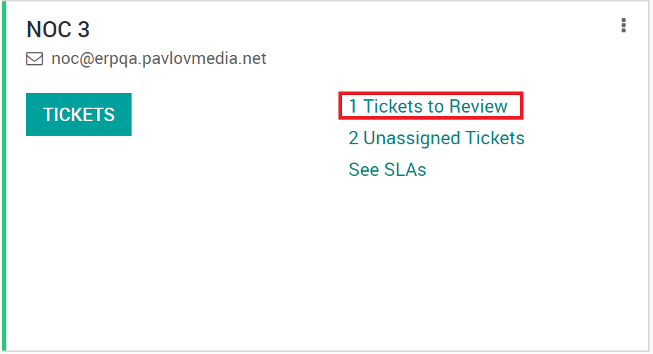

# Ticket Causes & Actions Taken

Ticket Causes and Actions Taken are added to allow for Tickets to have a Cause and Action Taken field. This is used for finding trends and reporting purposes. Since this is an add-on module, see document,” Helpdesk Enhancement – Cause & Action Taken Close Codes“ for more information.